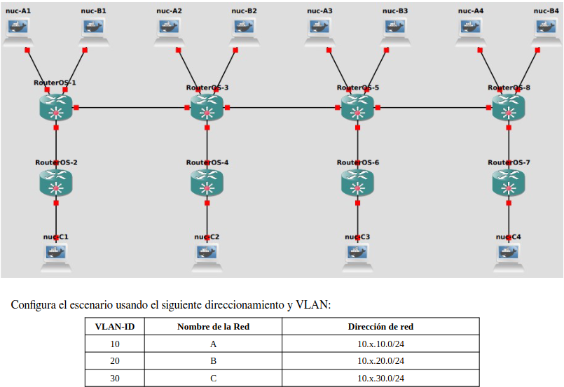

**R3:**

system/identity/set name=R3

interface/bridge/add vlan-filtering=yes

interface/bridge/port/add bridge=bridge1 interface=ether4

interface/bridge/port/add bridge=bridge1 interface=ether5

interface/bridge/port/add bridge=bridge1 interface=ether6

interface/bridge/port add bridge=bridge1 interface=ether1 pvid=10

interface/bridge/port add bridge=bridge1 interface=ether2 pvid=20

interface/bridge/vlan/add tagged=ether6,ether5,ether4,bridge1 vlan-ids=10 untagged=ether1 bridge=bridge1

interface/bridge/vlan/add tagged=ether6,ether5,ether4,bridge1 vlan-ids=20 untagged=ether2 bridge=bridge1

interface/vlan/add interface=bridge1 vlan-id=10 name=vlan10

interface/vlan/add interface=bridge1 vlan-id=20 name=vlan20

interface/vlan/add interface=bridge1 vlan-id=30 name=vlan30

ip/address/add interface=vlan10 address=10.15.10.1/24

ip/address/add interface=vlan20 address=10.15.20.1/24

ip/address/add interface=vlan30 address=10.15.30.1/24

ip/dhcp-server/setup

* vlan10
* vlan20
* vlan30

**R1:**

system/identity/set name=R1

interface/bridge/add vlan-filtering=yes

interface/bridge/port/add bridge=bridge1 interface=ether4

interface/bridge/port/add bridge=bridge1 interface=ether6

interface/bridge/port add bridge=bridge1 interface=ether1 pvid=10

interface/bridge/port add bridge=bridge1 interface=ether2 pvid=20

interface/bridge/vlan/add bridge=brigde1 tagged=ether6,ether4 untagged=ether1 vlan-ids=10

interface/bridge/vlan/add bridge=brigde1 tagged=ether6,ether4 untagged=ether2 vlan-ids=20

**input does not match any value of bridge**

**R2:**

system/identity/set name=R4

interface/bridge/add vlan-filtering=yes

interface/bridge/port/add bridge=bridge1 interface=ether1 pvid=30

interface/bridge/port/add bridge=bridge1 interface=ether6

interface/bridge/vlan/add bridge=bridge1 tagged=ether6 untagged=ether1 vlan-ids=30

**R5:**

system/identity/set name=R5

interface/bridge/add vlan-filtering=yes

interface/bridge/port/add bridge=bridge1 interface=ether4

interface/bridge/port/add bridge=bridge1 interface=ether5

interface/bridge/port/add bridge=bridge1 interface=ether6

interface/bridge/port add bridge=bridge1 interface=ether1 pvid=10

interface/bridge/port add bridge=bridge1 interface=ether2 pvid=20

interface/bridge/vlan/add bridge=brigde1 tagged=ether6,ether5,ether4 untagged=ether1 vlan-ids=10